**Muhammad Umar Ahmadzai**

**01/18/2018**

**Extra Assignment: Stamp Machine**

**Problem Statement:**

This program is going to be asking the user for the number dollars to input, and then it is going to output the number of stamps and the change that user is going to get. Each stamp equals to forty-four cents.

**Input/output Description:**

First, we are going to ask the user for the amount in cents.

cout << "Each stamp cost 0.44$ \nPlease enter the amount in dollars." << endl;

After the user inputs the amount, entered data will be inputted.

cin >> amount;

Here we define stamps, and change.

stamps= amount / 0.44;

change= (amount *100) % 44;

This gives an output to the user of the number of stamps, and the user’s change.

cout << "You are going to get " << stamps << "stamps, and your change is going to be " << change << "." << endl;

**Algorithm Development:**

Basically, we are creating three variables number, stamps and change. These variables are going to be defined, in which we are going to use modulus and division to find stamps, and change. User is going to be asked for dollars to input, and the machine is going to give the user result, number of stamps and change. One stamp equals to forty-four cents.

**Program Listing:**

#include <iostream>

using namespace std;

int main()

{

int amount, stamps, change;

cout << "Each stamp cost 0.44$. \nPlease enter the amount in dollars." << endl;

cin >> amount;

stamps= amount / 0.44;

change= (amount *100) % 44;

cout << "You are going to get " << stamps << "stamps, and your change is going to be " << change << " cents." << endl;

return 0;

}

**Sample test run of the program:**

Please insert the amount in dollars (each stamp costs 44 cents): 1

Number of stamps= 2, and your change is: 12 cents.

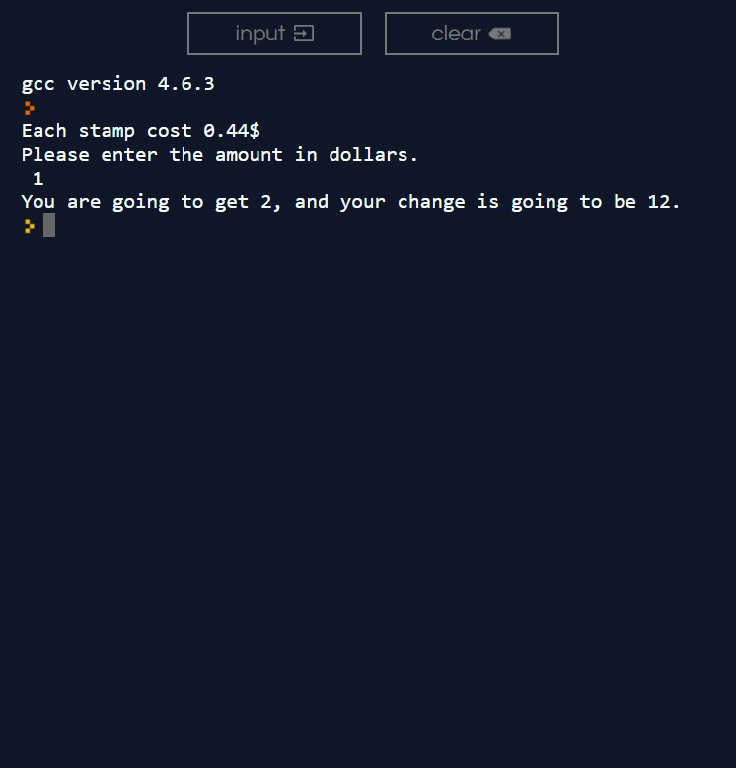

**Observation and Error Handling and general comments:**

Did not faced any errors.

**Conclusion:**

In conclusion, it asks user to input number of cents, and in output machine will provide the number of stamps and the change.